[Project title. This will flow through to the header]

[Insert an abstract here. Summarize your project in 400 words or less. It should fit on this page. Put your name, email, phone number and date below the abstract.]

[Name]  
[Email]  
[Phone number]  
[Date]

Contents

Introduction 1

What goes in the introduction? 1

The template 1

Heading 2 example 1

Heading 3 example 1

Method and data 1

Results 2

Conclusion 3

Tables

Table 1. Big 10 Football Standings November 23, 2021 2

Figures

Figure 1. Percentage change from a year ago in the U.S. Consumer Price Index for all urban consumers: All items in U.S. City Average, seasonally-adjusted 3

# Introduction

## What goes in the introduction?

Tell the reader what your overall question is, how you went about answering the question, and what your conclusion is. Part of this section should be devoted to an explanation of why your question is interesting or important.

## The template

Please use this template to make your report. It will help me to compare projects across students. Use the style formatting above to automatically create headings, and use “Insert Caption” under the References tab to automatically create captions for tables and figures.

* If you use the style formatting to automatically create headings you will be able to populate the table of contents.
* If you use captions you will be able to automatically create a list of tables and a list of figures. Make sure that you update the table of contents, and lists of tables and figures because they don’t automatically update. You right click on the list and select “update field” and then select the option to update the entire table.
* Have at least one table and at least one chart. How many tables and charts is best will vary depending upon the report. Exercise your judgment about presentation of tables (borders, right justification versus center justification, headings, layout etc.). Don’t let tables span one page to the next unless the table is so large is cannot fit on one page.

Your report must have the headings: Introduction, Method and data, Results, and Conclusion. The report should be only five pages.

The this template has examples of the following styles: Heading 1, Heading 2, Heading 3, and a bulleted list paragraph. It also has examples of a table and figure.

## Heading 2 example

### Heading 3 example

* Bullets example
  + Bullets example
    - Bullets example

# Method and data

In the method and data section, make a complete description of the data you analyzed, and the sources. The reader needs this information because the reader wants to know how generalizable the results are. Everyone’s project is different so interpret the description below in the context of your project.

Tell the reader how many companies you analyzed, and over what time period. Tell the reader how many days, weeks, months, or years or data you analyzed (this varies by project) and what the overall number of observations are. For example, if you had annual data, Apple 2020 and Apple 2019 represent two observations. The reader can determine whether results from 1980 are relevant for decision-making in 2021. Address whether your sample is of companies currently trading, or also includes inactive companies. Address whether other filters were applied, e.g. index membership, analyst coverage, market capitalization cut-off, sales cut-off. Address the industry coverage.

Tell the reader what your research method is. Often we write reports with separate method and data sections. But in your case, the report is only five pages, and it is challenging for you to write separate method and data sections. If is easier write the method in the same section as you use to describe the data.

# Results

In the results section, explain your findings in the context of your research question. Some of you may elect to discuss statistical significance. But I have not emphasized statistical significance because we need to make resource allocation decisions. There is enough time to analyze one large dataset on a narrow research question, including extracting data, writing code and writing a five-page report. There is not enough time to also teach statistical inference. But we have discussed basic research methods.

* For example, one student is considering whether high or low leverage is associated with high or low price/earnings ratio, and that consideration has to be made by comparing firms in the same industry (because leverage and P/E ratios vary systematically across industries.
* A student is comparing whether enterprise value/sales ratios on profitable companies are higher today than just before the market peak of March 2000; again, this comparison is being made across industries because valuation ratios and profitability vary by industry.

In summary, your analysis is largely descriptive and you won’t necessarily measure the probability that you have observed a result by chance (the *p-*value). Some of you will include *p-*values on the basis of your prior statistical knowledge, but that is a choice that can be made by each individual student.

Here is an example of a table. Because I inserted a caption before making the table I can use Cross-reference under the References tab to refer to the table using above/below, table number or the table number and heading. For example, I can write “in the table ” and put in “below” using the Cross-reference button; or I can write “in ” and put in the table number using the Cross-reference button; or I can write “in ” and put in the entire heading.

Table . Big 10 Football Standings November 23, 2021

|  |  |  |
| --- | --- | --- |
| Team | Conference | Overall |
| **Big 10 East** |  |  |
| Ohio State | 8-0 | 10-1 |
| Michigan | 7-1 | 10-1 |
| Michigan State | 6-2 | 9-2 |
| Penn State | 4-4 | 7-4 |
| Maryland | 2-6 | 5-6 |
| Rutgers | 2-6 | 5-6 |
| Indiana | 0-8 | 2-9 |
| **Big 10 West** |  |  |
| Wisconsin | 6-2 | 6-3 |
| Iowa | 6-2 | 9-2 |
| Purdue | 5-3 | 7-4 |
| Minnesota | 5-3 | 7-4 |
| Illinois | 3-5 | 4-7 |
| Nebraska | 1-7 | 3-8 |
| Northwestern | 1-7 | 3-8 |

Here is an example of a figure. Using Cross-references I can refer to the figure , I can refer to , and I can refer to .

Figure . Percentage change from a year ago in the U.S. Consumer Price Index for all urban consumers: All items in U.S. City Average, seasonally-adjusted

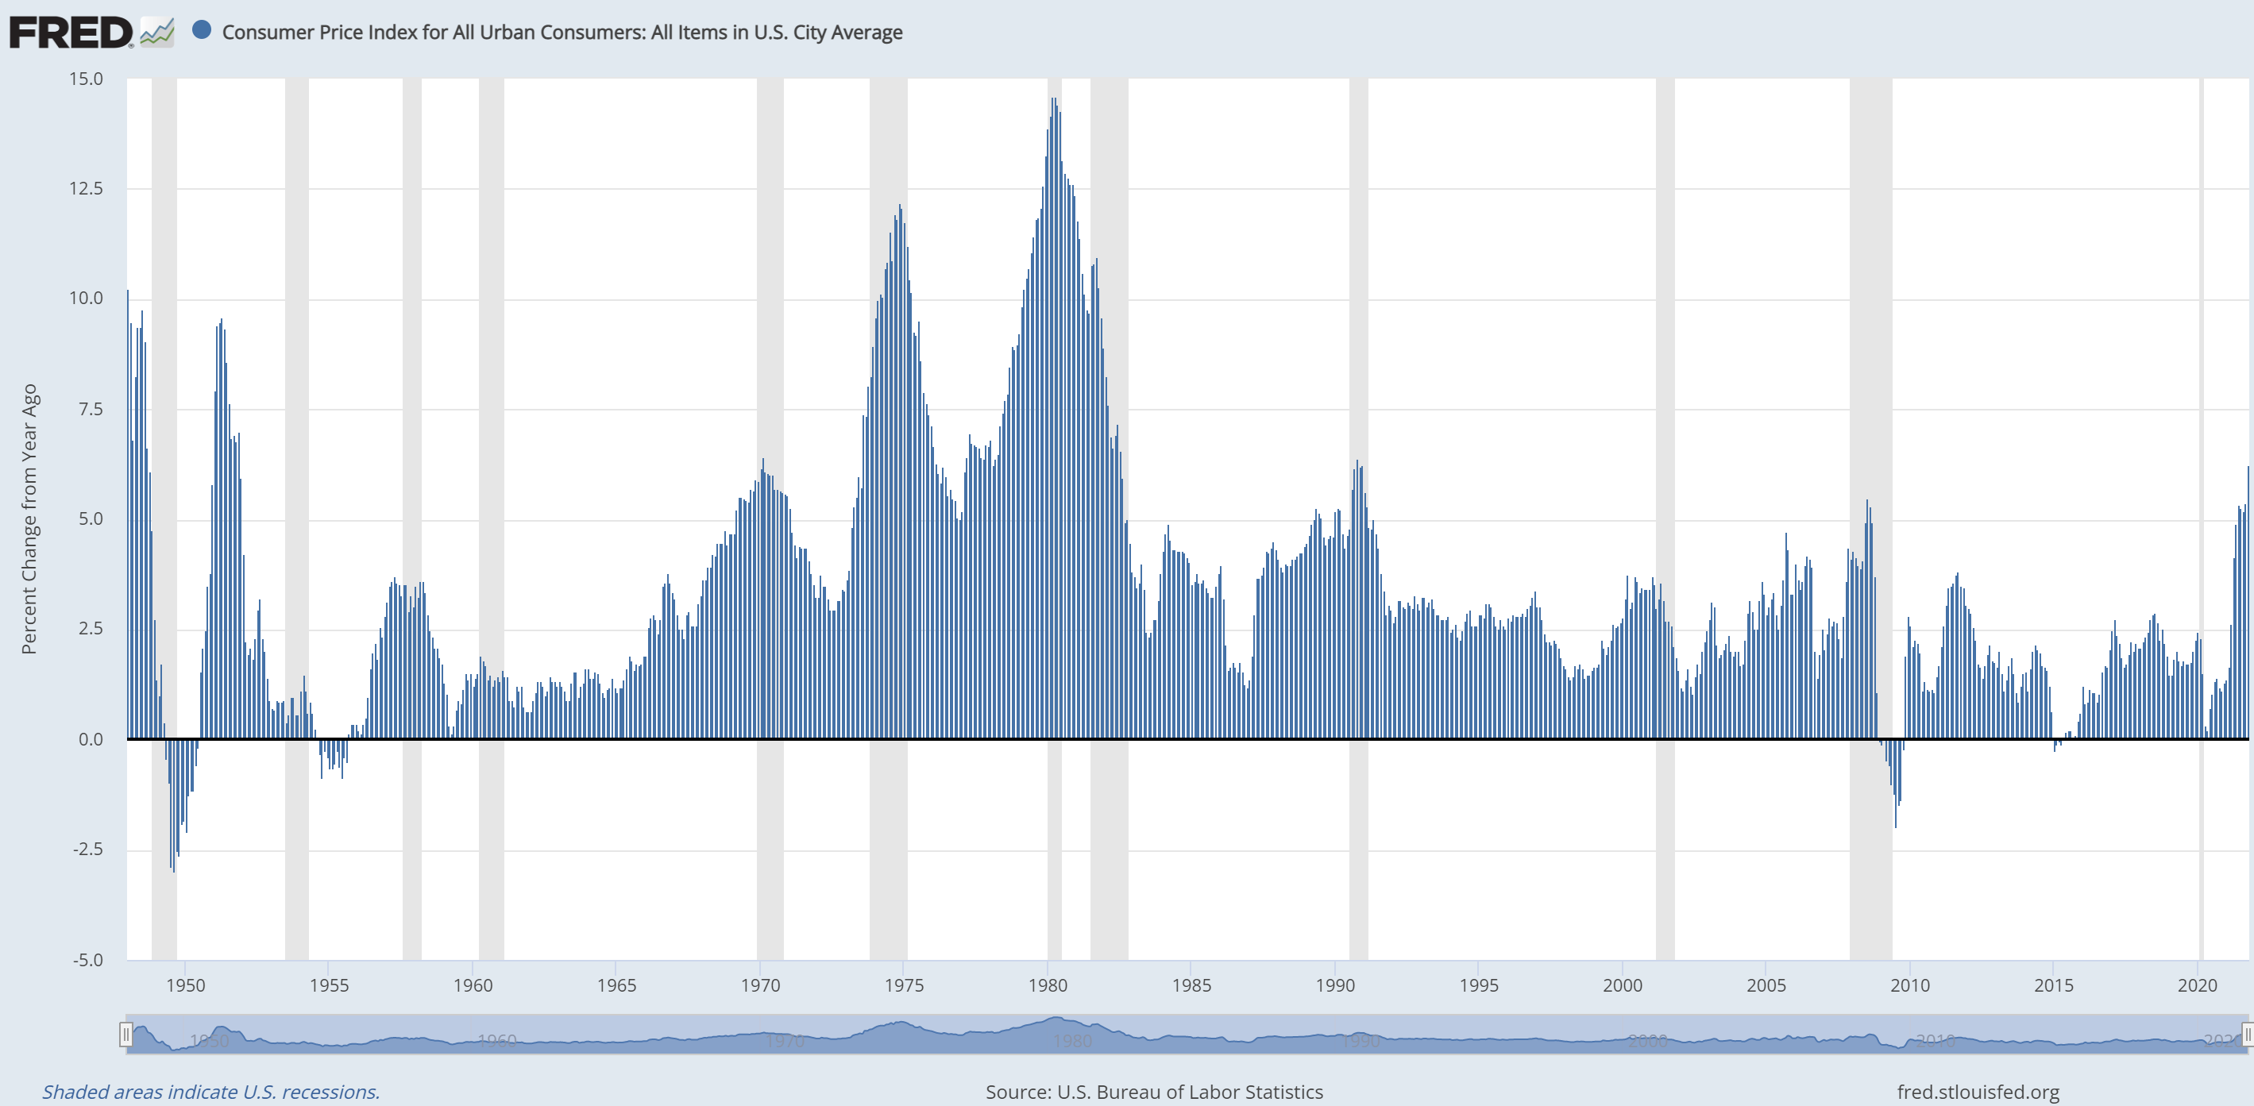

# Conclusion

Reach your conclusion in this section. Given that you only have five pages, this section will be short.